# Abstract

Here we describe high-density SNP discovery and genetic map construction for a Brassica rapa recombinant inbred line population. We also use the genotype data from the population to detect and remedy putative genome mis-assemblies and to assign scaffold sequences to their likely genomic locations. These improvements to the assembly represent 7.1-8.0% of the annotated Brassica rapa genome. We demonstrate how this new resource is a significant improvement for QTL analysis over the current low-density genetic map

SNP list

Genotype bin pipeline

Scaffold assembly

Fix missassembly

New Genetic Map

Conversion between genetic and physical distance

Introduction

The Brassicaceae is a family of plants that collectively provides 10% of human food calories (ref). Along with the model plant species Arabidopsis, there are X number of Brassicaceae genome sequences that have been published in the last 15 years (refs). Included in this list is Brassica rapa, a physiologically and morphologically diverse diploid species that has 87% gene exon similarity to Arabidopsis thaliana (ref). This makes Brassica rapa a making a great candidate for comparing and translating knowledge of biological processes into a crop species from Arabidopsis.

Brassica rapa has a genome size of 250 Gb spread over 10 chromosomes A01-A10 (genome paper). The genome consortium has a public release at version 1.5 that is a significant improvement over version 1.0 (weblink). However, there are still many large scaffolds that have not been placed due to various problems with assembly. These scaffolds equate to X% of the remaining sequence in the genome. An increasingly common way to place scaffolds and contigs is to use recombination probabilities between molecular markers that occur on those scaffolds so they can be placed in relative positions if general genome assembly fails. The most time consuming part of this step is making a genetic mapping population and completing the sequencing on the progeny (refs). We chose a heavily used recombinant inbred line population developed by (Iniguez-Luy *et al.* 2009).

## Instead of conducting genotype by sequencing for these lines, we instead chose to sequence RNA at enough coverage from all the individuals in the population that we could call SNPs from this data. This technique has been used before in humans (refs), but limited in scope in plants. Name species where this was done. (Trick *et al.* 2009; Lai *et al.* 2012; Koenig *et al.* 2013)

## The advantage is that the sequencing can be used for both genotyping of individuals in the population and for mapping expression QTL thus getting more out of the sequencing and trying to find SNPs in coding regions of genes that are more likely to be causative SNPs. cSNPs

## Through our investigation of this data, we have discovered potential errors in the parental population through SNP discovery, genotyped all the individuals in the BraIRRI population for 1475 markers, and created a saturated genetic map that can improve mapping resolution compared to the existing map. These resources and findings are useful for anyone using this well studied population, the general Brassica rapa community, and anyone interested in comparative genomics within the Brassicaceae.

# 

# Methods

RNA-seq library preparation and sequencing

RNA-Seq libraries were prepared using high-throughput Illumina RNA-Seq library extraction protocol (Kumar *et al.* 2012). The enriched libraries were then quantified on an Analyst Plate Reader (LJL Biosystems) using SYBR Green I reagent (Invitrogen). Once the concentration of libraries was determined, a single pool of all the RNA-Seq libraries with in each block was made and then run on Bioanalyzer (Agilent, SantaClara) to determine the product size of the final pool. Finally each pool is adjusted to a final concentration of 20 nM and sequenced on 7 lanes on Illumina Hi-Seq 2000 flowcell as 50-bp single end reads. All the failed samples from all 5 blocks were run on 2 additional lanes.

RNA-Seq Read Processing

<http://hannonlab.cshl.edu/fastx_toolkit/>

<https://github.com/mfcovington/auto_barcode>

<http://www.bioinformatics.babraham.ac.uk/projects/fastqc/>

<https://github.com/mfcovington/SNPtools>

https://github.com/MaloofLab/devisetty-g3-2014/blob/master/SNP-detection.md

Pre-processing and mapping of Illumina RNA-Seq raw reads was done as described earlier (Devisetty *et al.* 2014) with one exception. The raw reads were quality filtered with fastq_quality_filter with parameters [-q 20, -p 95]. The qualified de-multiplexed reads were then mapped to B. rapa reference genome (Chiifu version 1.5) using BWA v0.6.1-r104 (Li and Durbin, 2009) with parameters [bwa_n 0.04] and the unmapped reads are in turn mapped with TopHat with parameters [splice-mismatches 1, max-multihits 1, segment-length 22, butterfly-search,, max-intron-length 5000, library-type fr-unstranded].

Genotyping

Individuals in the population were genotyped first using the reference set of cSNPs that were called as part of (Devisetty *et al.* 2014) pipeline. However, once merging all the outputs for the RILs there were inconsistencies suggesting that the parents of the population had more then one parent. The R500 SNPs were consistent across all the individuals whereas the IMB211 SNPs were not suggesting that the parental seed stock has cross pollination contamination. There was not any evidence that the R500 seed stock was contaminated. This led us to approach this using an alternative genotyping strategy by combining all the individual replicates per RIL into a single file to call SNPs compared to the reference genome. Each SNP was then filtered by comparing it to the genotype of the R500 parent. At each SNP, each RIL was genotyped as R500 or the alternate allele. All these SNPs needed to match up with the one another. At each step there were quality scores and filters that were applied using custom Perl scripts (found here). Only SNPs that met our quality scores were considered.

Genotypic Bin Creation

All of the SNPs were then assembled along the chromosomes according to their genomic location. Aligning all the individuals in the population allowed us to calculate unique recombinations that are present in the population. These unique bins were determined by custom Perl scripts (found here). SNPs located in the middle of the genotypic bin were selected to be used for placement of scaffolds and the creation of the genetic map.

## Genetic Map Construction

Using one unique SNP per genotype bin, we created a saturated genetic map. The genetic map was constructed using the chromosomal position of each of the SNPs as a starting point for marker ordering along the chromosomes. Each chromosome was treated as a large linkage group and each SNP was tested for linkage disequilibrium with all other SNPs with the R/QTL package (Broman et al. XXXX, Supplemental Data X) in the R statistical environment (@R-ref). The larger gaps in the map is where there is little marker information and corresponded to centromeric regions (Figure 9b). These large gaps caused a small problem when ordering the markers and connecting each of the chromosomal arms in the correct order. In these ordering chromosomes X, Y, Z we used the physical position of the SNPs to connect the two arms in the correct order. The orientation of the scaffolds cannot be determined with the current methods because of we are limited by the size of the population. Therefore, scaffolds are placed between adjacent bins determined by lowest recombination probabilities.

## 

## QTL Comparisons

To demonstrate an improvement in coverage in mapping physiological traits, we remapped two traits from (Brock *et al.* 2010)that used the existing genetic map. As the fairest comparisons between maps, marker regression was performed using the scanone() function in RQTL with 10,000 permutations to determine the significance cutoff (Figure 9c).

# 

# Results and Discussion

## 

## Deep RNA sequencing of a RIL population and its parents

We performed deep RNA sequencing of 124 members of a recombinant inbred line (RIL) population derived from the Brassica rapa accessions R500 and IMB211. We sequenced each member of the RIL population with X-X replicates at an average of X reads mapped per replicate for a combined mean of X reads mapped per RIL. We have previously described the deep sequencing of R500 and IMB211 (Devisetty *et al.* 2014)and use that data in this current study. These datasets will eventually be used in analyses of differential gene expression; however, we are currently using them for variant discovery and creation of a genetic map resource.

## 

## R500 vs. IMB211 polymorphism identification

To identify polymorphisms within the RIL population, we first looked for SNPs and INDELs between R500 and IMB211, the parents of the population. We used an approach previously described for the identification of polymorphisms between R500 and IMB211 with an earlier version of the *Brassica rapa* genome annotation, v1.2 (Devisetty *et al.* 2014). In the current study, we used v1.5 of the genome for all mapping and informatics work.

This set of R500 vs. IMB211 polymorphisms was used to genotype each member of the RIL population. Based on the crossing scheme used to create the RIL population, we would expect homozygous regions of contiguous R500 alleles alternating with homozygous regions of contiguous IMB211 alleles. When using this polymorphism set to genotype the RILs; however, there were several regions where R500 and IMB211 alleles were interspersed with no apparent pattern.. This suggests that a different parental source may have been used to construct this RIL population.

To test this hypothesis, we merged all of the sequence data from the individual RILs and then genotyped the merged dataset (Figure 1A). Given the relatively large size of the population and the expected introgression frequency and distribution, polymorphisms generated by comparing the actual parents of the RIL population should be segregating with approximately equal allelic frequency in this merged data set (black dots in figure). Most polymorphisms did display this expected distribution; however, there were several large regions that were not segregating, instead they were monomorphic for one of the putative parents of the population (indicated as orange or blue dots in the figure). Nearly all of these regions matched the putative R500 alleles. The primary exception is the bottom of chromosome A03, which displays a gradual transition from equal R500:IMB211 allelic frequency to nearly all IMB211. This pattern is consistent with segregation distortion and

One explanation for the non-segregating regions is that the seed stock of one or both of our parental lines was not actually the true parent of the population. To evaluate this possibility, we sequenced several additional seed stocks of R500 and IMB211. The genotypes of all *X* R500 seed stocks were consistent with one another across all polymorphisms. There were, however, at least *X* distinct genotypic variants within the *X* IMB211 seed stocks. Therefore, we proceeded to work under the assumption that the sequences from the R500 seed stocks that we have provide a reasonably accurate genotypic representation of the R500 parent used to create the R500-IMB211 RIL population.

## 

## Population-based SNP discovery

Due to the uncertainty surrounding the IMB211 parent of the RILs, we switched to a population-based approach for discovering SNPs. This new strategy involves identifying variants within the RIL population and using the R500 data to determine which is the R500 allele and which is the IMB211 allele for each SNP. Using this approach, we identified 146,027 SNPs across *B. rapa*'s ten chromosomes (Table 1).

Using the population-based SNPs to genotype the merged RIL sequence data produces the expected allele frequencies throughout the entire genome (Figure 1B). Over *X*% of the genome is within of a SNP; however, there are several regions with few or no SNPs. There are two primary reasons for these SNP-free regions. Most are likely gene-poor regions or regions of genes with insufficient expression under our experimental conditions (e.g., growth conditions, age, tissue, genotypes, etc.). We also found a few regions where there are significant numbers of expressed genes, but no SNPs between members of the RIL population. (These regions primarily correspond to the homozygous regions of Figure [rils-merged.parent-based-snps.png] and, therefore, likely represent regions that are very similar between the seed stocks used to generate this RIL population.

## 

## Genotyping the RIL population

Using the information on the entire population instead of just the parents provides many more observations of the potential SNPs in the population.

* Sample RIL genotype plot
* Boundary detection and bin construction
* Composite genotype table/plot (starting with detecting and merging boundaries of individual RILs)

## Finding and fixing genome misassemblies

* Composite plot suggests misassemblies
  + Add other evidence that supports this
* Look at pairwise distances between bins
  + individual plots and overview plot (overview first? then individual plots help determine which bins should be where.)
  + Use this info to rearrange bins (have table with rearrangement stats.)
  + Plot overview and composite map following rearrangement

## Incorporating scaffold sequences into the genome

In the current version of the *B. rapa* genome annotation (v1.5) there are 40,357 scaffolds that have not been incorporated into any of the ten chromosomes. These scaffolds range in size from 100 bp to 938 Kbp and represent 1,411 genes spanning 27.5 Mbp. For comparison, there are 39,609 genes within the 256 Mbp of annotated chromosomal sequence. Given that the scaffolds contain about as many genes as would be expected on one third of an average chromosome, we decided to extend our strategy for fixing genome misassemblies to estimate the approximate chromosomal locations of the scaffolds.

We identified 3,070 SNPs across 339 of the 40,357 scaffolds. This corresponded to a sufficient number of SNPs (10+) for only 47 scaffolds. For each of these 47 scaffolds, we found a chromosomal bin with identical or near identical genotypes, indicating very close genetic linkage. This degree of similarity made it trivial to incorporate these 47 scaffolds into the chromosomal bin structure. The incorporated scaffolds range in size from 429 to 884,746 bp and are enriched for larger scaffolds (Figure ). The N50 values for incorporated and unincorporated scaffolds are 436.0 Kbp and 11.8 Kbp, respectively. Although we have incorporated only 0.1% of the scaffolds into the genome, the incorporated scaffolds represent nearly 7 Mbp of sequence, a disproportionately high 25% of all scaffold sequence (Table [incorporated-scaffolds-stats.png]).

While most of the incorporated scaffolds represent a single genotype bin, seven are comprised of multiple bins. Scaffold000164, for example, includes 65 annotated genes across six distinct genotype bins within its 313.7 Kbp sequence. One scaffold, Scaffold000191, had bins mapping to two different chromosomes, indicating that it was misassembled. Therefore, we split its two bins and assigned them to the appropriate chromosome locations (5 genes/28.2 Kbp to A01 and 24 genes/104.1 Kbp to A05).

Possible reasons for the enrichment of larger scaffolds within the set of incorporated scaffolds include: (1) larger scaffolds are more likely to include expressed genes and, therefore, SNPs that we can detect and (2) larger scaffolds may be more likely to be accurate representations of a contiguous region within the genome. This second point is based on the assumption that large scaffolds were able to be assembled perhaps due to more abundant, more consistent, and/or more convincing experimental support than small scaffolds. The large scaffolds that we were unable to incorporate because they *...*

## High-density genetic map

From the available SNP data we were able to create a genetic map with ten linkage groups corresponding to the 10 chromosomes of *Brassica rapa* ((Table [genetic-map-summary.png])). The map contains 1482 genotyped markers for 124 RILs and is completely saturated based on recombination events existing in the population. The maximum spacing between markers is 36.6 cM with an average spacing between markers of 0.7 cM (Table X), The overall map distance of 1045.6 cM. The new map is compared to the existing map containing 224 markers with an average spacing of 1.5 cM (@iniguez-luy_development_2009). Furthermore, the new marker set has physical anchors to the genome for each marker and includes newly placed scaffolds on chromosomes X, Y, Z.

## 

## Conclusions

# Conflicts of interest

# The authors declare no conflicts of interest.

**Acknowledgments**

The authors wish to thank Maloof lab members for helpful discussion and reading of the manuscript. RJC Markelz was supported by a NSF Postdoctoral Research Fellowship in Biology (IOS-1402495). This research was supported by NSF grant IOS-0923752 to CW and JNM.

**Supporting Information**

Supporting Code for genetic map construction can be found at:

https://github.com/rjcmarkelz/brassica_genetic_map_paper

# Figures

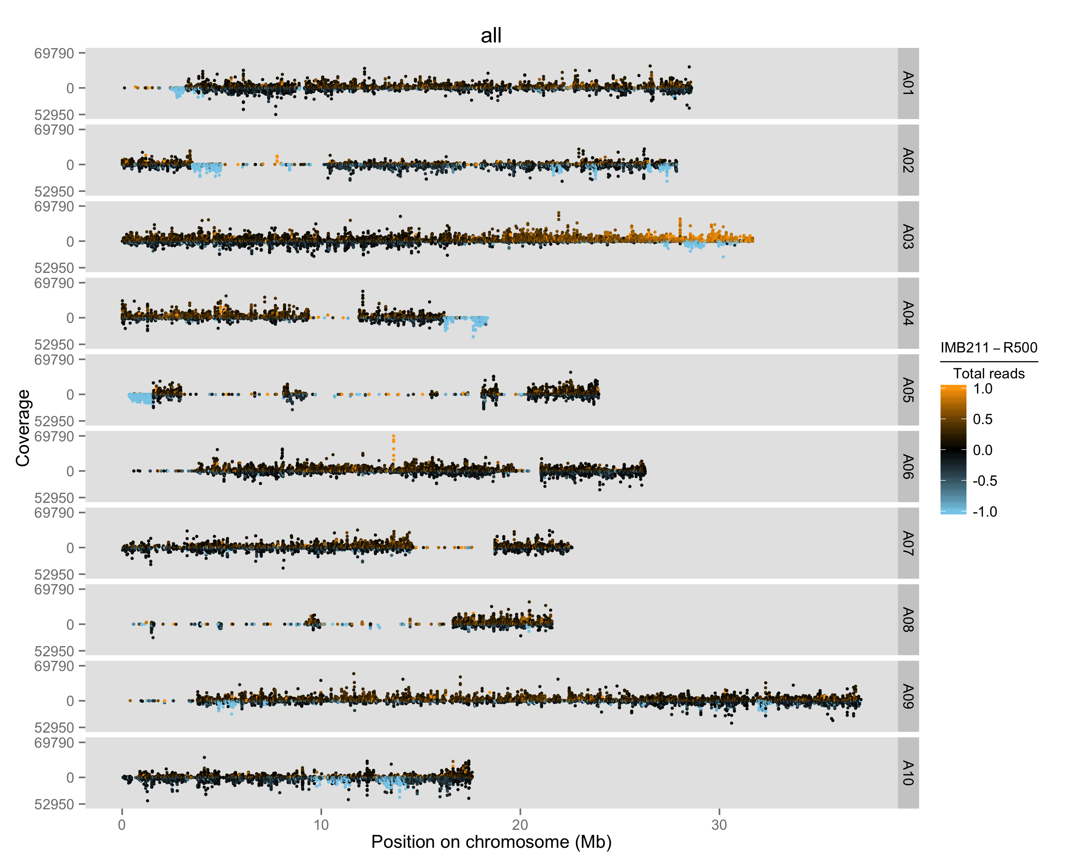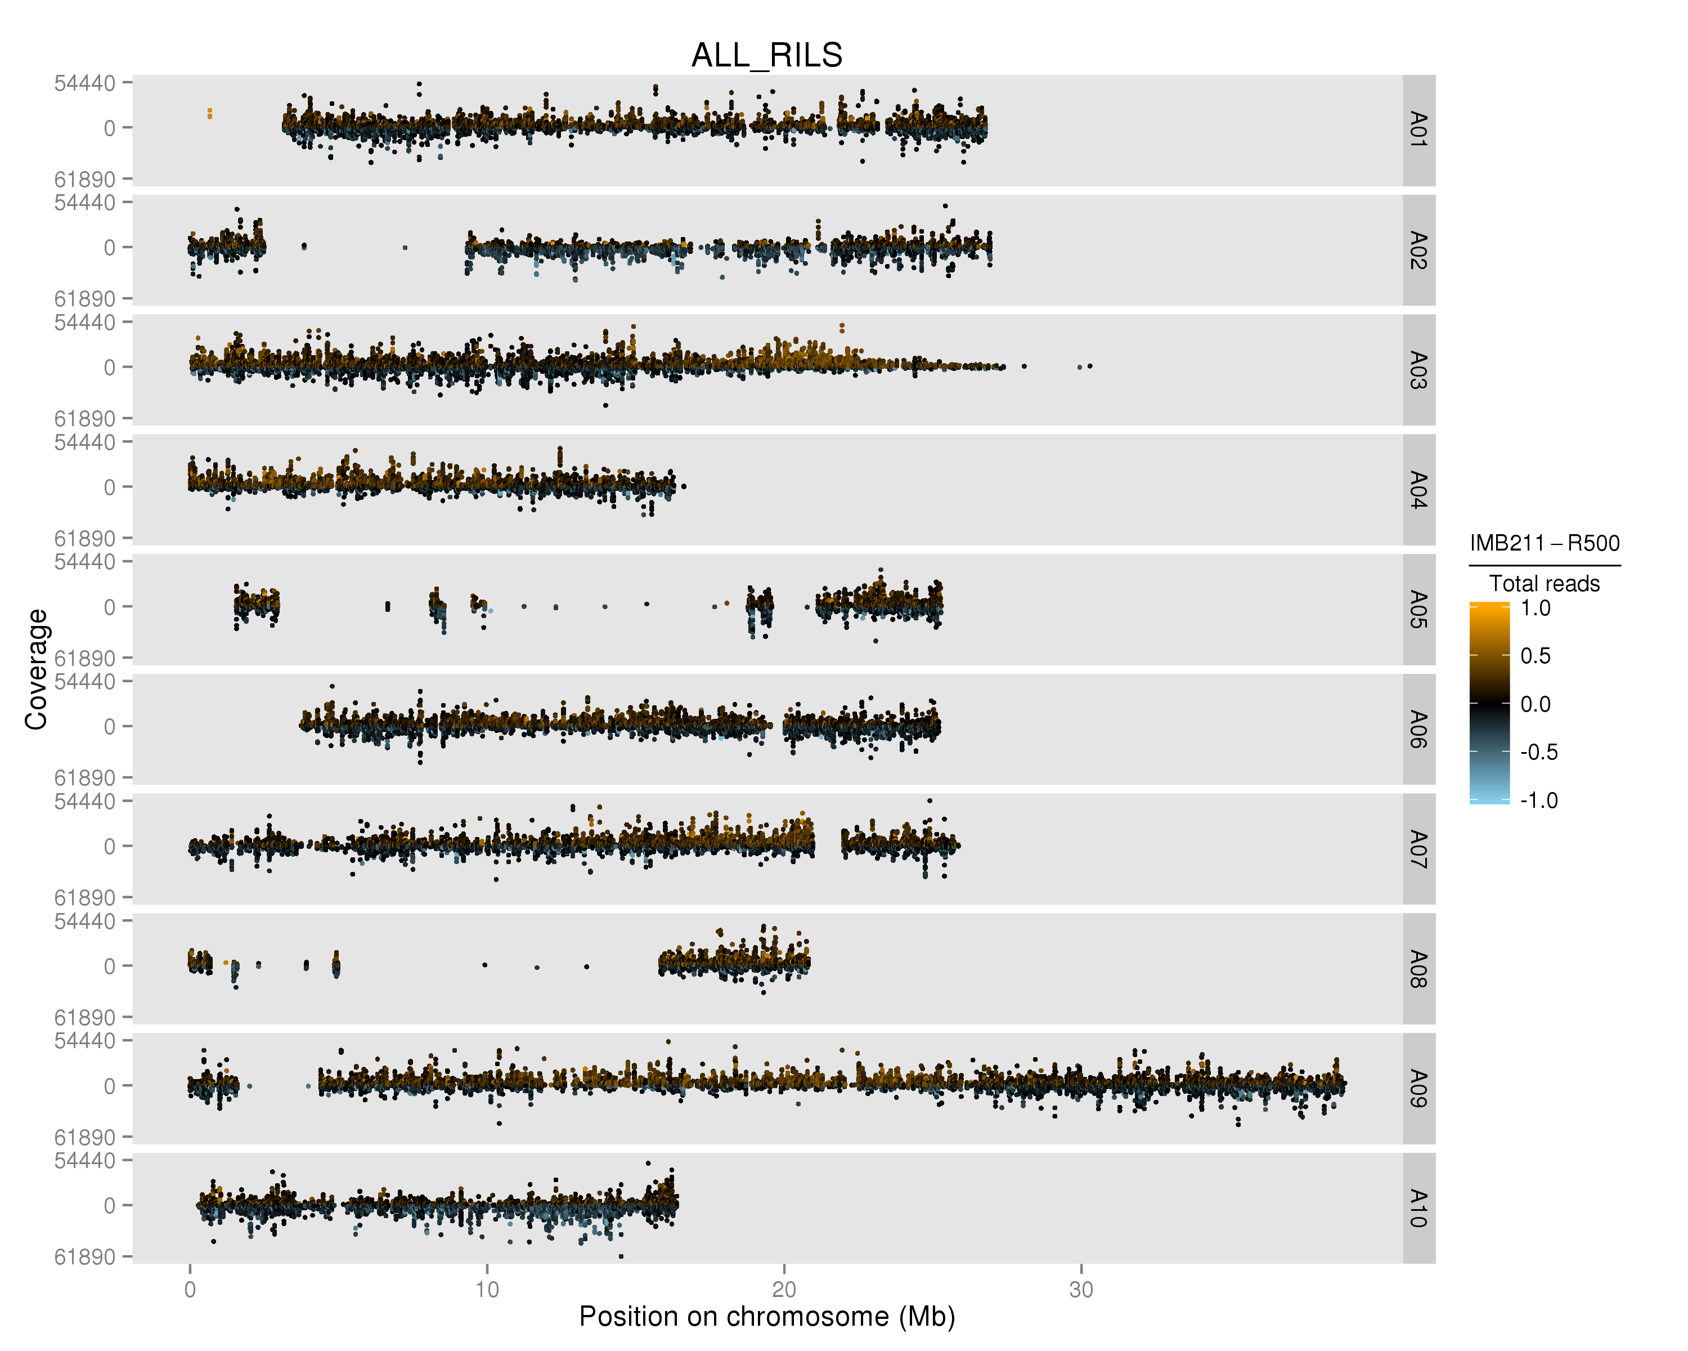

Figure 1. Plot of merged data from all RILs genotyped using the parent-based SNP set (left) and the population based SNP set (right). Each of the B. rapa ten chromosomes are displayed (A01-A10) with counts coverage of each SNP at each physical position on the chromosome in megabases (Mb). The color indicates the relative ratio of coverage between R500 and IMB211 for every SNP. Black is equal coverage, orange is more IMB211 and blue is more R500.

Use the new IMB211 name for these SNPs.

Table 1. SNP counts at different steps of the SNP discovery pipeline. The percentage of SNPs located on chromosomes or scaffolds remaining after each step are shown in parentheses. The first percentage is relative to the initial set of SNPs and the second percentage is relative to the set of SNPs from the previous step.

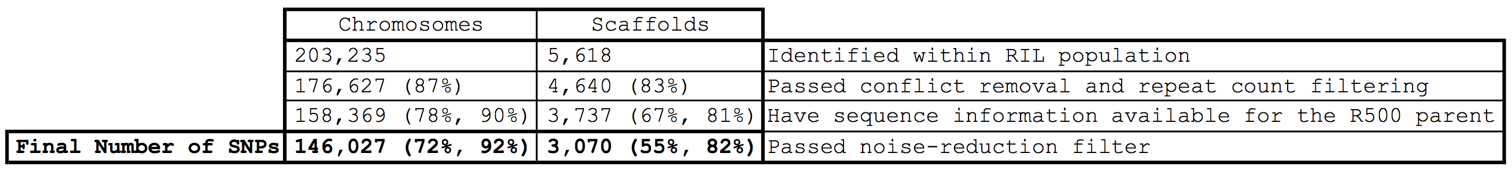

Table 2. Incorporated scaffolds represent a disproportionately high amount of scaffold sequence. Percentages of scaffold subset counts and total lengths relative to the set of all scaffolds are shown in parentheses.

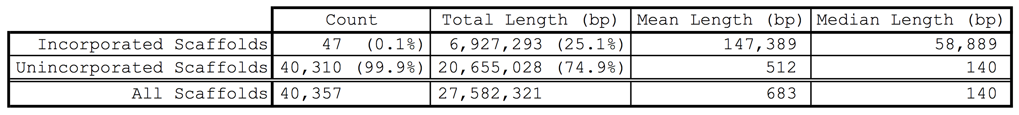

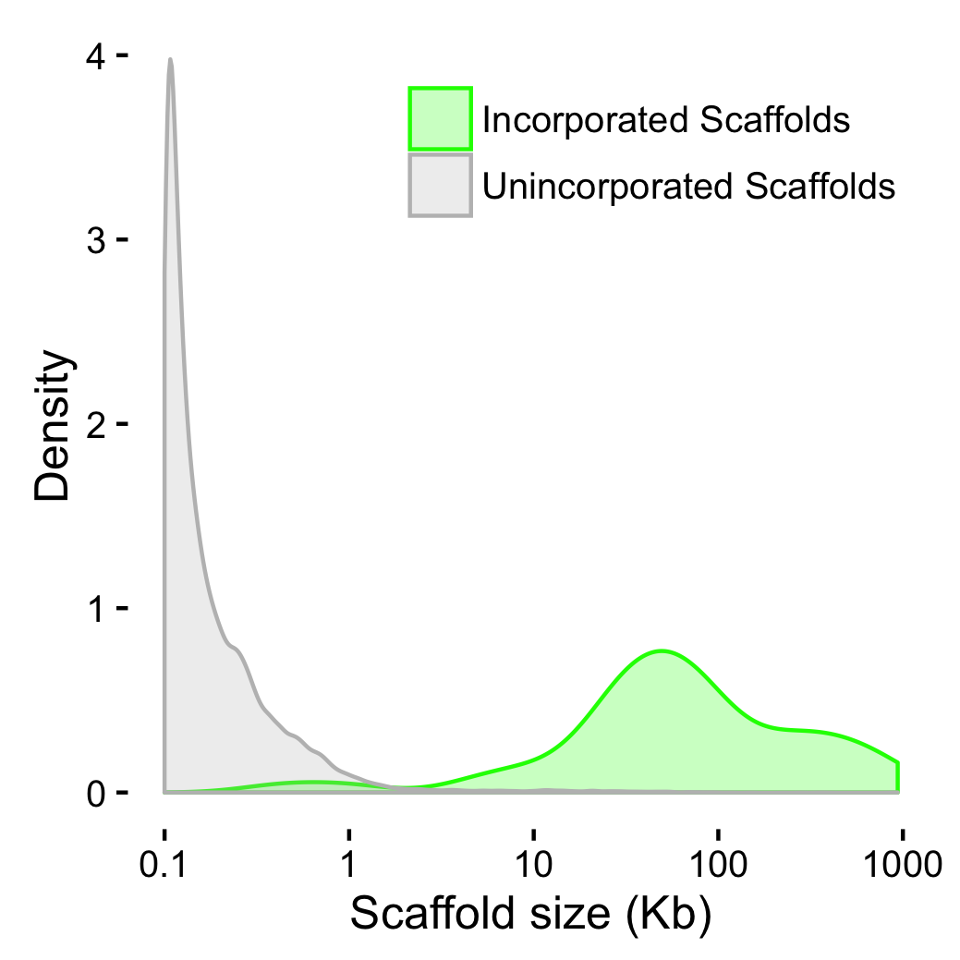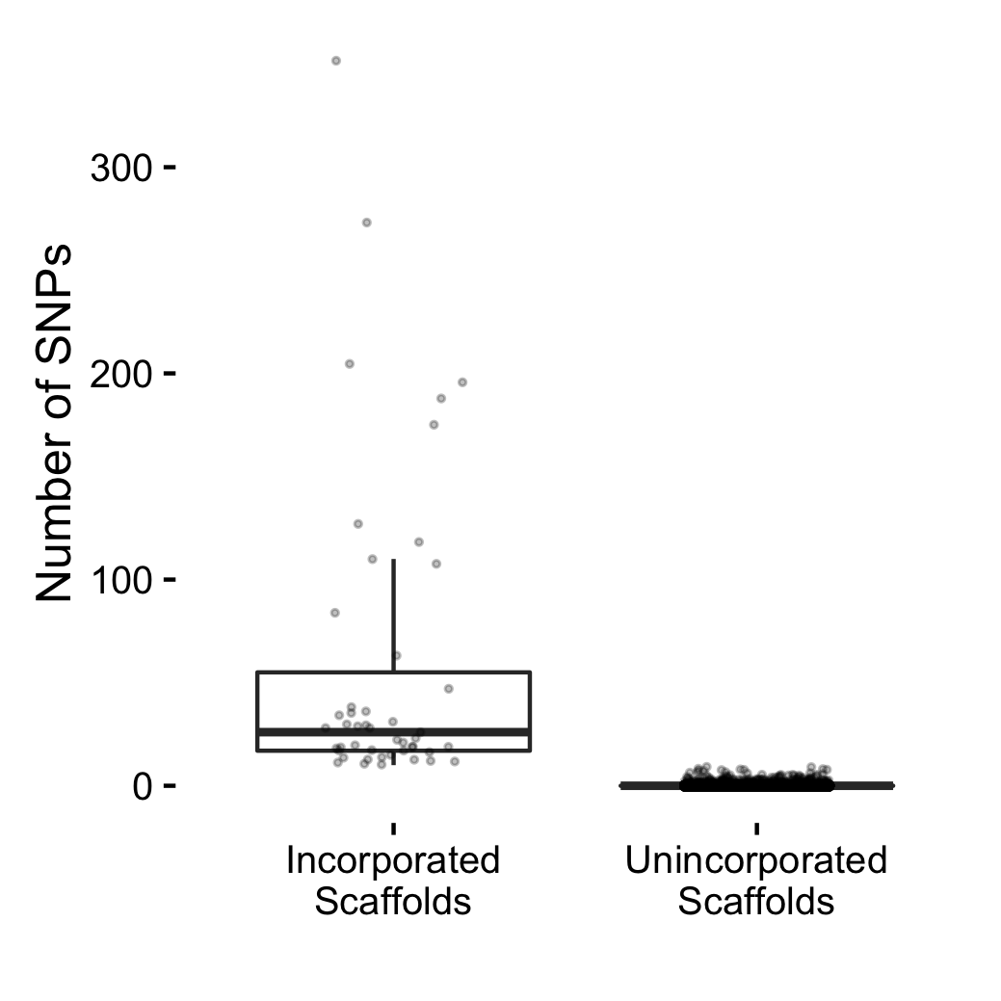

Figure 3. (A) Number of SNPs per scaffold. (B) Density distributions of scaffold sizes. Newly incorporated scaffolds are shown in green and unincorporated scaffolds are shown in gray.

composite-map.original.cluster-by-chr.pdf

Figure 4. Composite population genotype map with the position in physical distance across all ten chromosomes. Each RIL is represented as a single row displaying the genomic region inherited from IMB211 (Orange) or R500 (Blue). Small heterogeneous regions are represented in black.

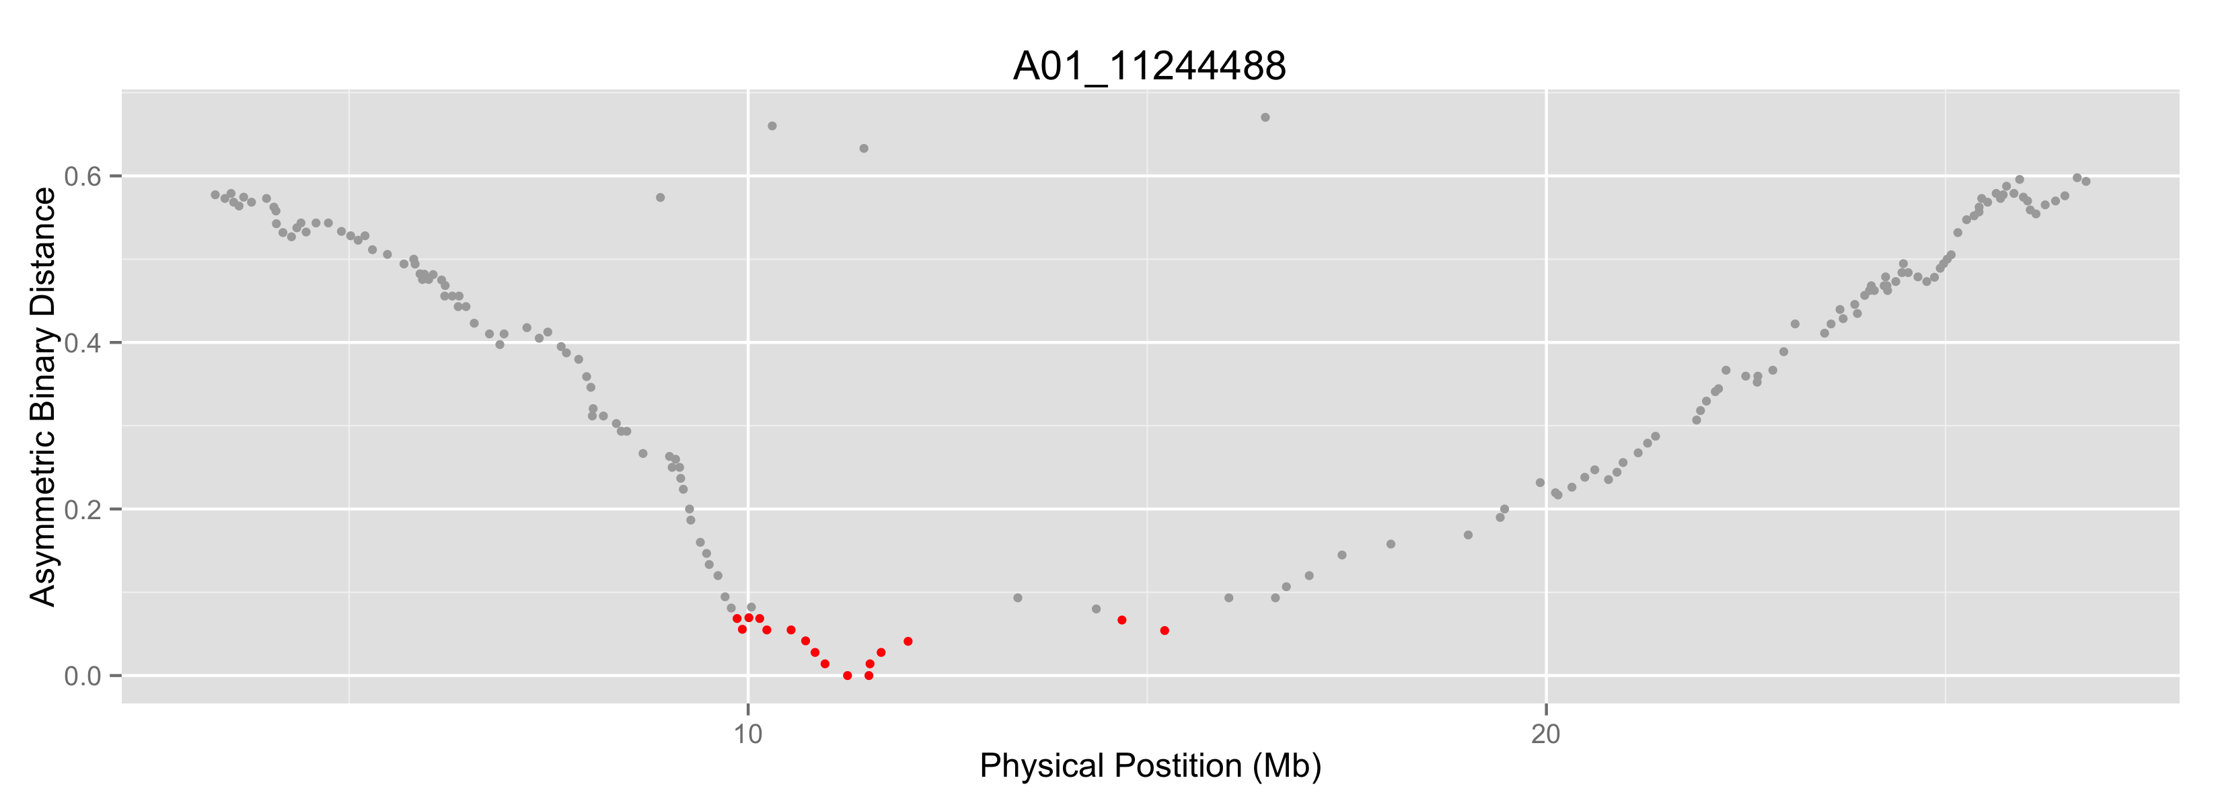

Figure 5. Representative asymmetric binary distance analysis plot for a single marker located on A01. Markers with 90% correlation are indicated in red. Misplaced markers are circled in blue.

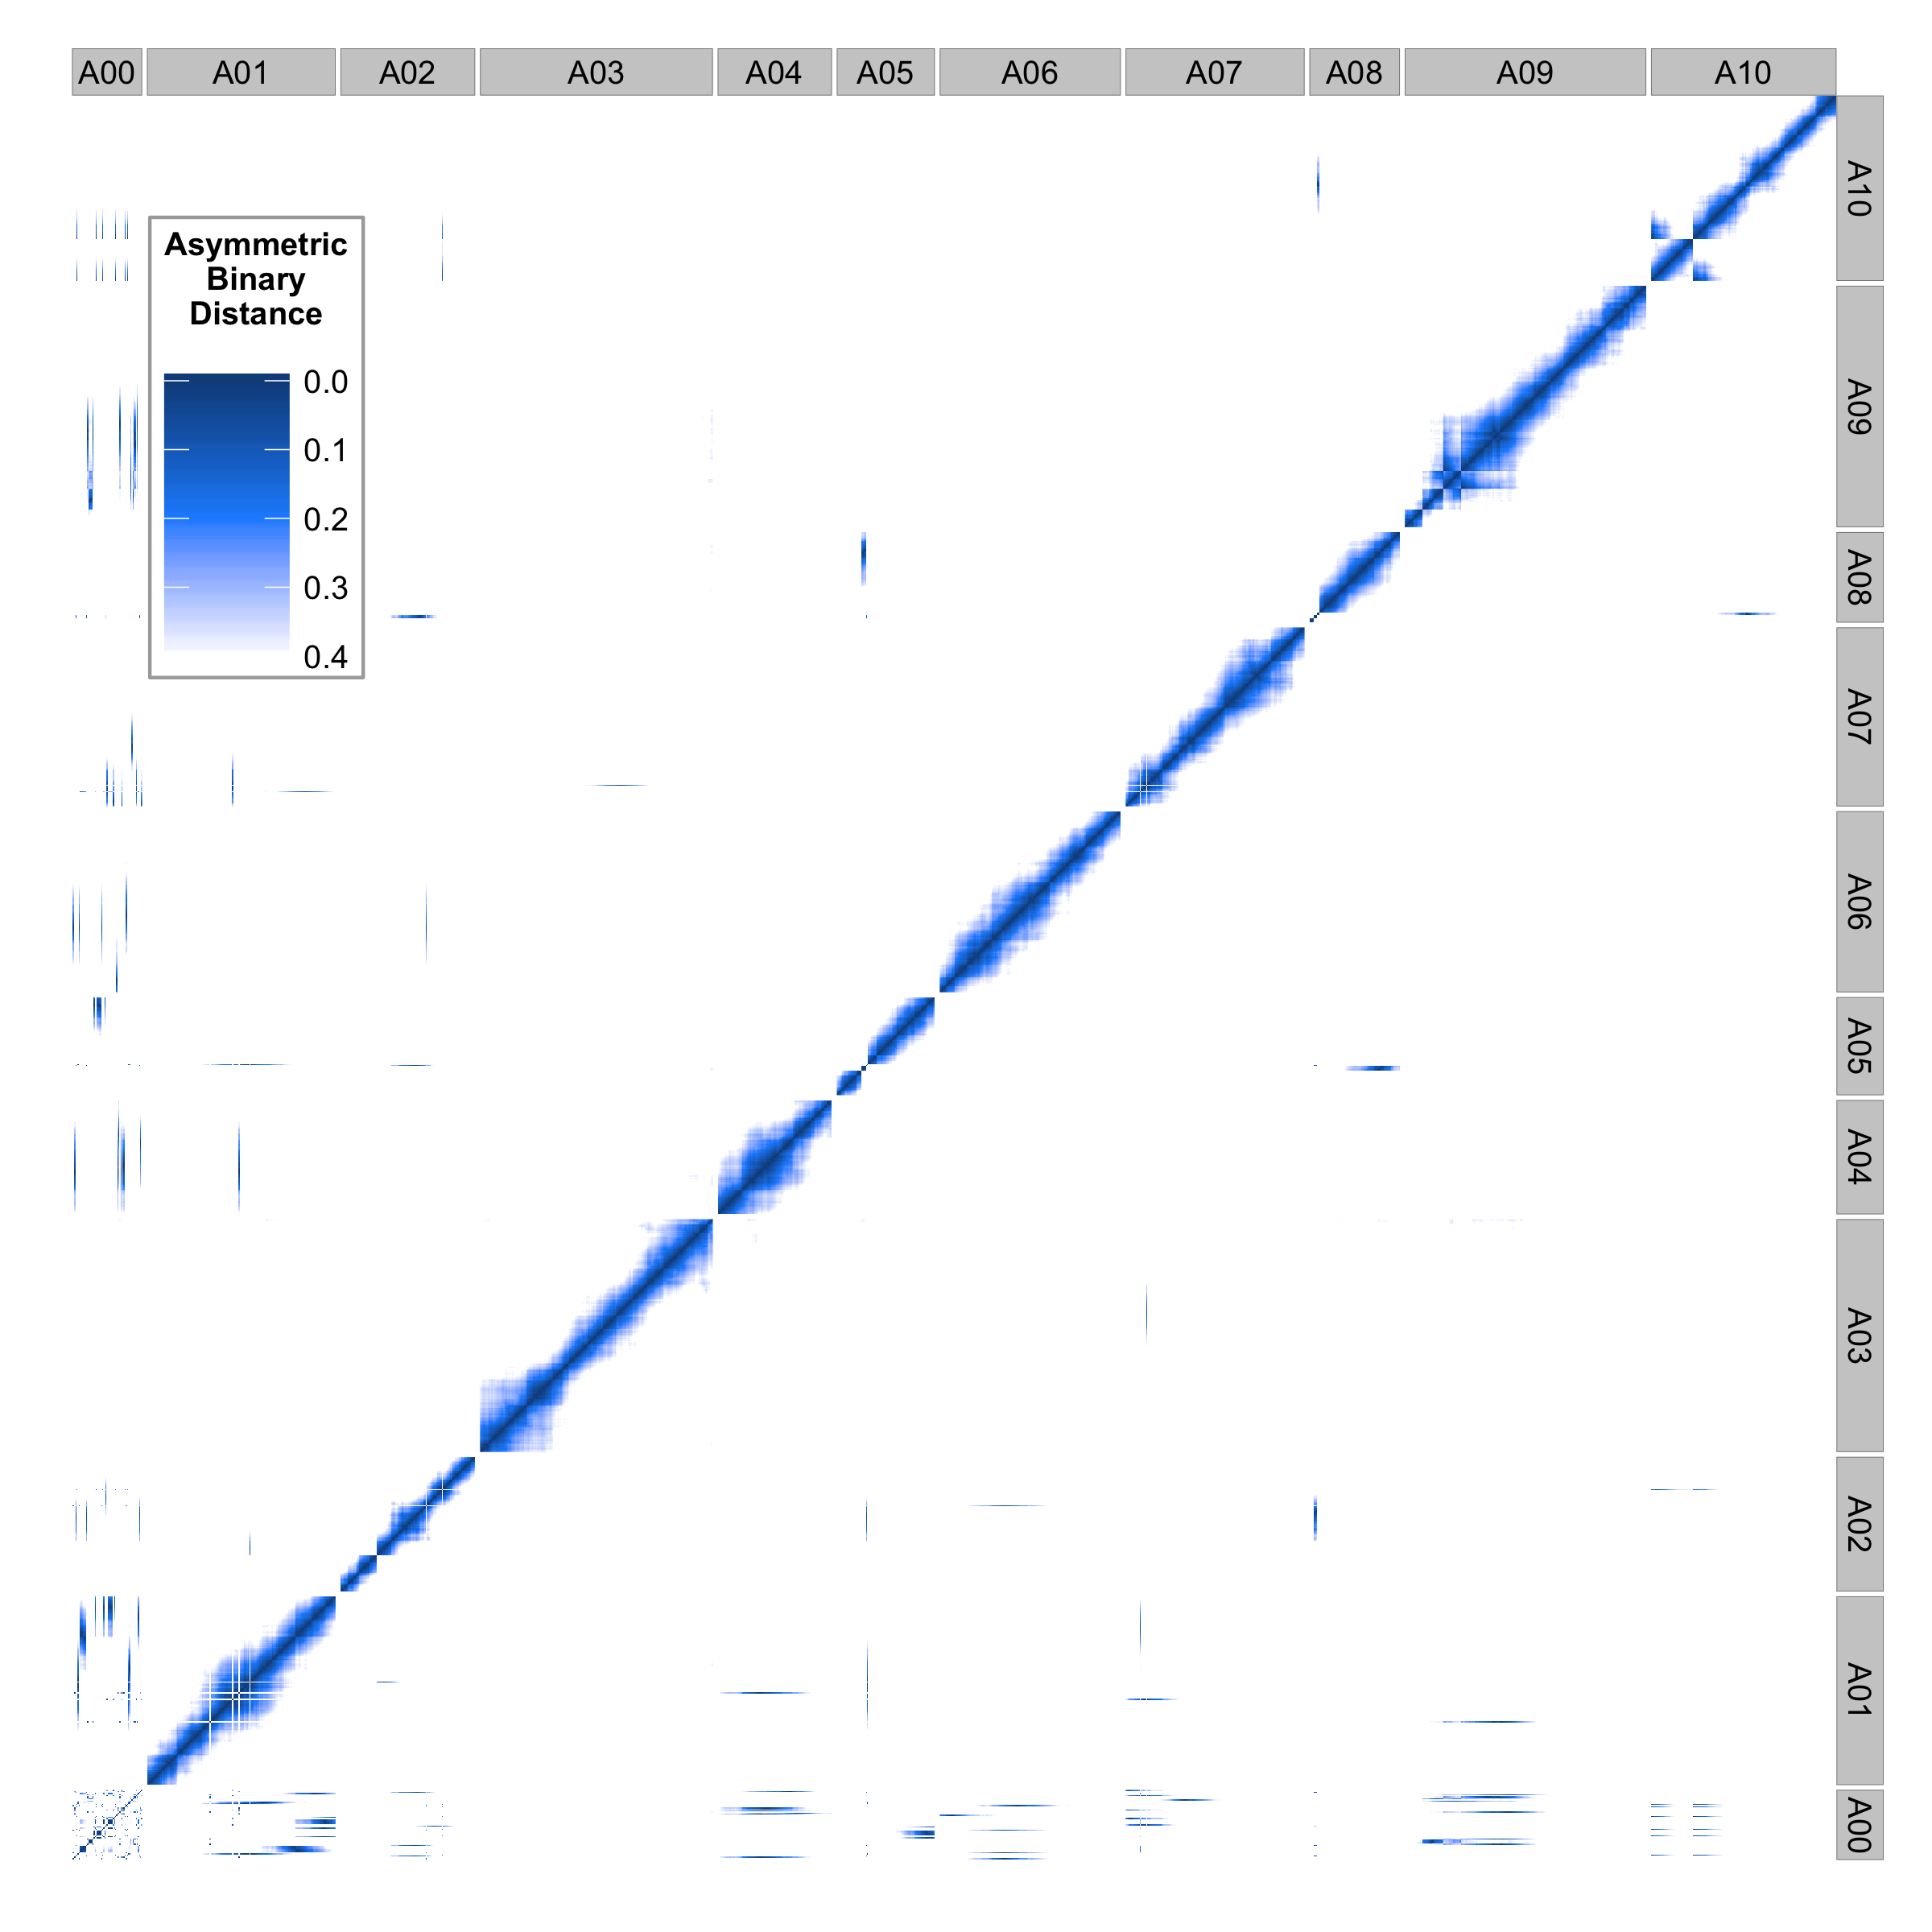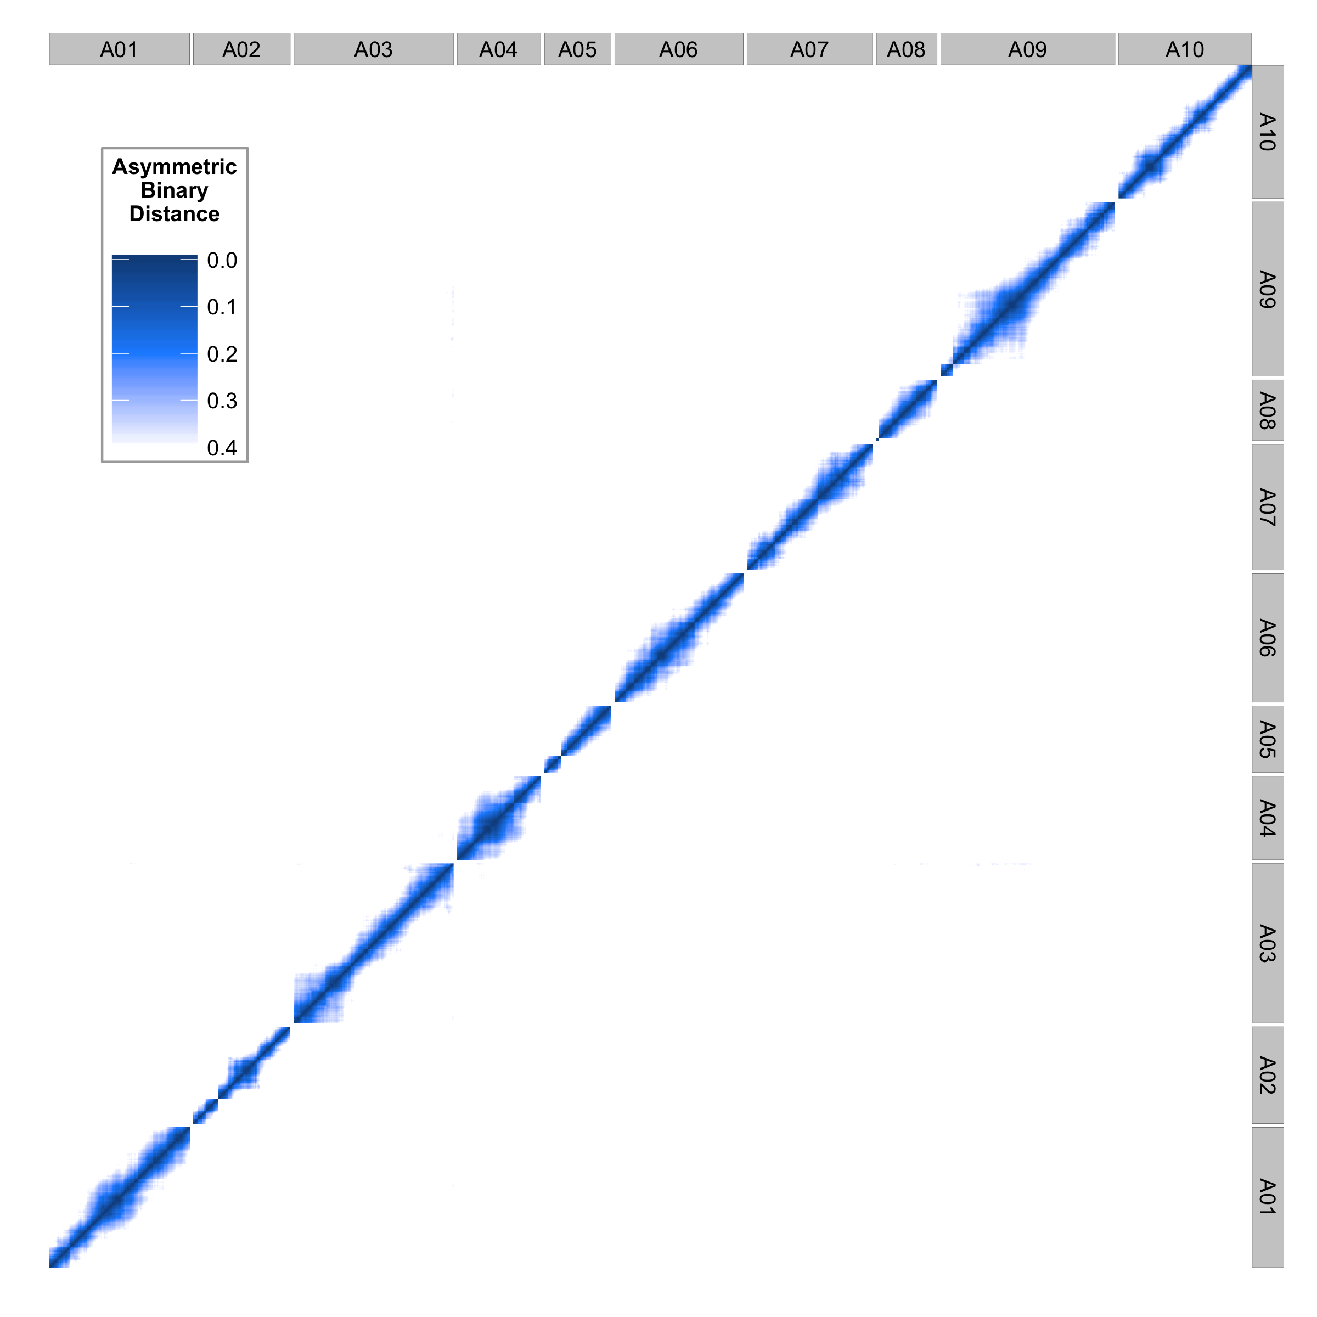

Figure 6. Asymmetric binary distance plots for each marker compared against every other marker before (A) and after (B) marker rearrangement. Dark blue indicates high correlation while white indicates no genetic correlation.



Figure 7. Physical position versus genetic position of each marker for chromosome A10 using genome version 1.5 (left) and fixed inversion using recombination information (right).



Figure 8. Physical position versus genetic position of each marker for chromosome A01 using genome version 1.5 (left) and placed scaffolds using recombination information (right).

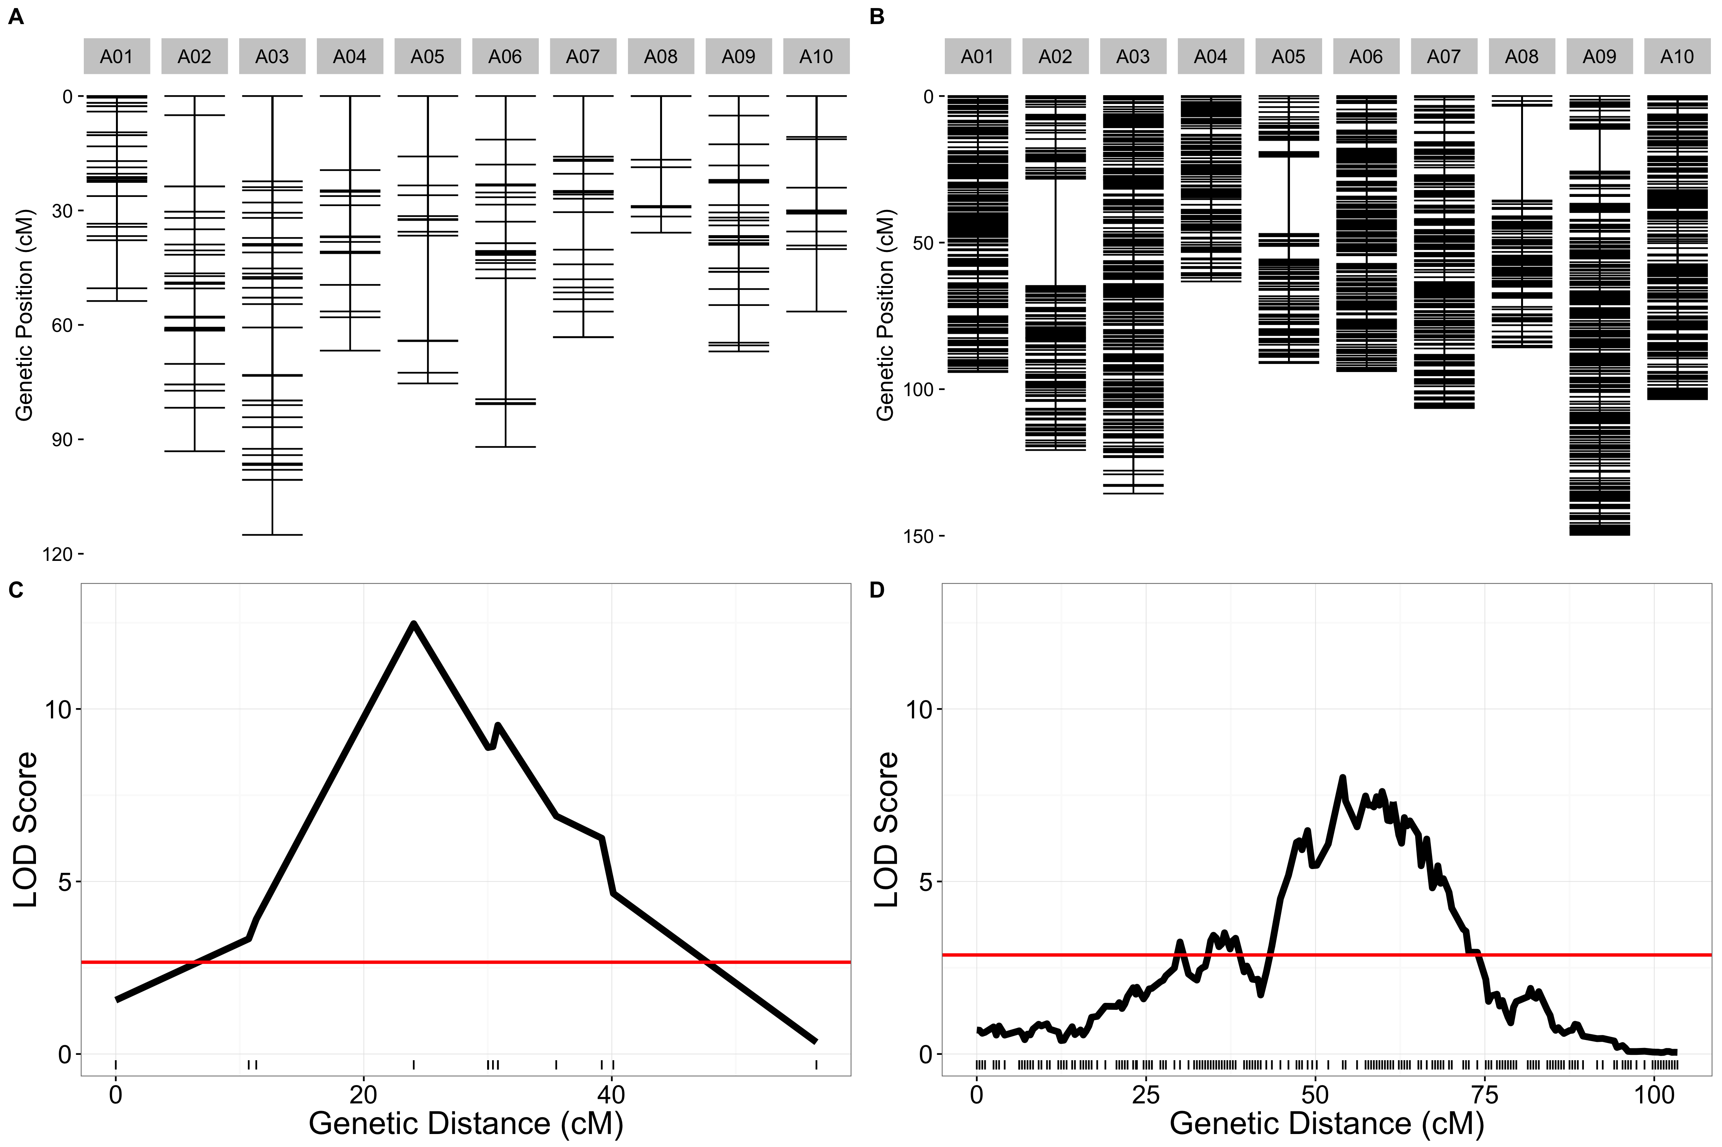

Figure 9. Old and new genetic map comparisons. Genetic markers for each chromosome are displayed in centimorgan distance (cM) for the old (A) and new (B) genetic maps. Comparison of likelihood odds scores for flowering time QTL using the old (C) and new (D) genetic maps.



Figure 10. Example spline regression for converting between genetic and physical distance for subsetting genomic ranges for genes underlying significant QTL.

Bibliography

Brock, M. T., J. M. Dechaine, F. L. Iniguez-Luy, J. N. Maloof, J. R. Stinchcombe *et al.*, 2010 Floral Genetic Architecture: An Examination of QTL Architecture Underlying Floral (Co)Variation Across Environments. Genetics 186: 1451–1465.

Devisetty, U. K., M. F. Covington, A. V. Tat, S. Lekkala, and J. N. Maloof, 2014 Polymorphism Identification and Improved Genome Annotation of Brassica rapa Through Deep RNA Sequencing. G3 Genes Genomes Genet. 4: 2065–2078.

Iniguez-Luy, F. L., L. Lukens, M. W. Farnham, R. M. Amasino, and T. C. Osborn, 2009 Development of public immortal mapping populations, molecular markers and linkage maps for rapid cycling Brassica rapa and B. oleracea. Theor. Appl. Genet. 120: 31–43.

Koenig, D., J. M. Jimenez-Gomez, S. Kimura, D. Fulop, D. H. Chitwood *et al.*, 2013 Comparative transcriptomics reveals patterns of selection in domesticated and wild tomato. Proc. Natl. Acad. Sci. 110: E2655–E2662.

Kumar, S., T. W. Banks, S. Cloutier, S. Kumar, T. W. Banks *et al.*, 2012 SNP Discovery through Next-Generation Sequencing and Its Applications, SNP Discovery through Next-Generation Sequencing and Its Applications. Int. J. Plant Genomics Int. J. Plant Genomics 2012, 2012: e831460.

Lai, K., C. Duran, P. J. Berkman, M. T. Lorenc, J. Stiller *et al.*, 2012 Single nucleotide polymorphism discovery from wheat next-generation sequence data. Plant Biotechnol. J. 10: 743–749.

Trick, M., Y. Long, J. Meng, and I. Bancroft, 2009 Single nucleotide polymorphism (SNP) discovery in the polyploid Brassica napus using Solexa transcriptome sequencing. Plant Biotechnol. J. 7: 334–346.